**DAILY ONLINE ACTIVITIES SUMMARY**

|  |  |  |  |  |  |  |  |  |
| --- | --- | --- | --- | --- | --- | --- | --- | --- |
| **Date:** | **9-6-2020** | | | | | **Name:** | **Pavana P** | |
| **Sem & Sec** | **6A** | | | | | **USN:** | **4AL17CS057** | |
| **Online Test Summary** | | | | | | | | |
| **Subject** | | **CGV**  **CNSC** | | | | | | |
| **Max. Marks** | | **30**  **60** | | **Score** | | | **27**  **26** | |
| **Certification Course Summary** | | | | | | | | |
| **Course** | **Build an IOTS Blockchain Network for a supply chain.** | | | | | | | |
| **Certificate Provider** | | | Cognitive classes | | **Duration** | | | 4 hours |
| **Coding Challenges** | | | | | | | | |
| **Problem Statement:**  1. Write a Python to implement Perfect Sum Problem  2.write a java Program to print smallest and biggest possible palindrome word in a given string  3. Python Program to count even and odd numbers  4. Write a Java Program to remove all white spaces from a string without using replace() | | | | | | | | |
| **Status: Completed** | | | | | | | | |
| **Uploaded the report in Github** | | | | | **YES** | | | |
| **If yes Repository name** | | | | | **DAILY STATUS** | | | |
| **Uploaded the report in slack** | | | | | **YES** | | | |

.

**Online Test :**

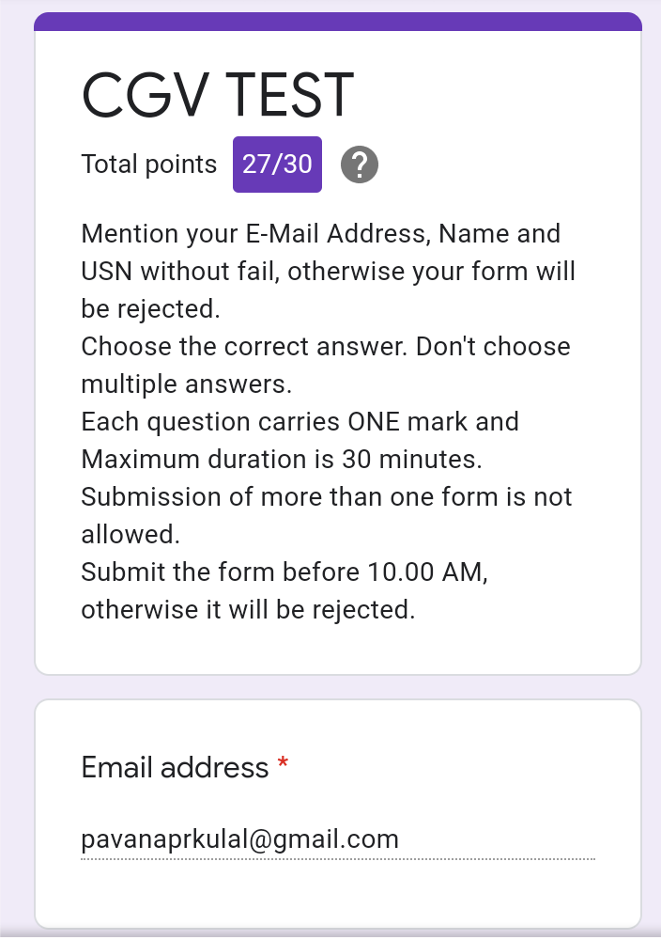Subject:-CGV

**Subject: CNSC**

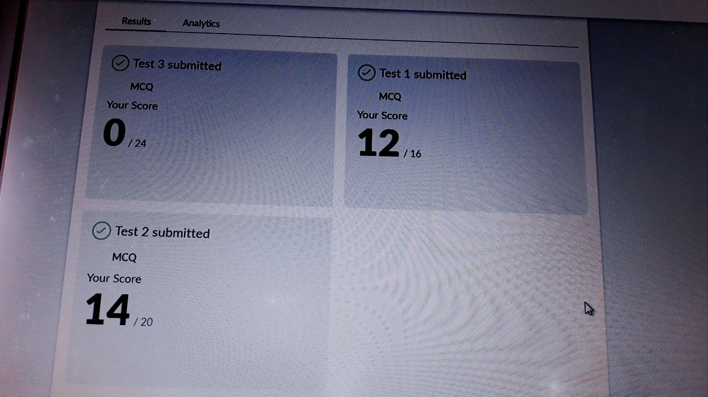

**Certification Course Details:**

**Build an IOT Blockchain network for a supply chain :**

Today I have completed these topics:

1.Understand the imported Node - RED flows.

2.Start particle Electron flow.

3.Blockchain REST API flow.

4.IOT Asset dashboard flow.

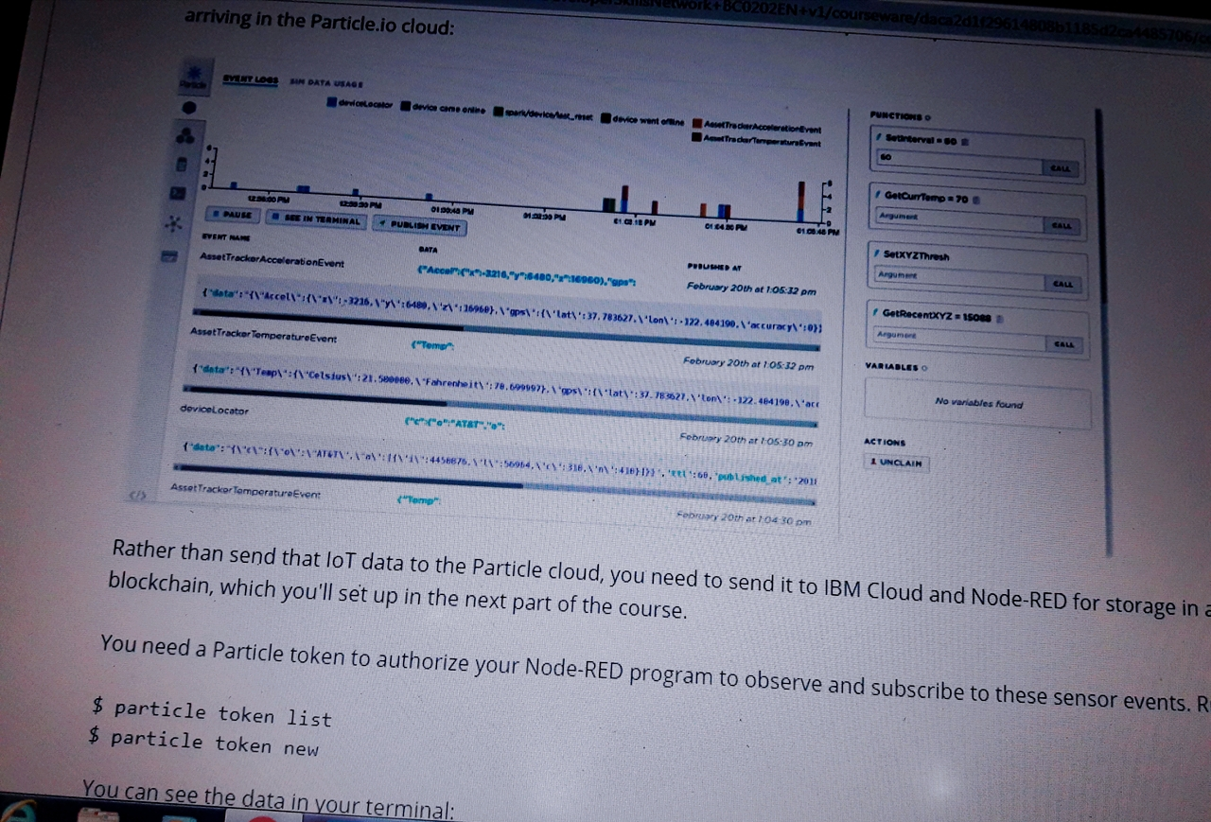

**Coding Challenges Details:**

**https://github.com/pavana-p-kulal/DAILY-STATUS/tree/master/9-6-20/Online%20Coding**